

Quantitative Development Assignment Report

Kevin Tan YueJun

Table of Contents
1. Introduction 3
2. Exploratory Data Analysis 3
2.1 OHLCV Consistency Check 3
2.2 Gap Analysis 3
2.3 Data Visualisations 4
2.3.1 Price Behaviour, Volume Patterns, Return Distributions and Temporal Characteristics 4
2.3.2 Seasonality Figures and Correlations 5
3. Rules Based Trading Strategy 7
3.1 Performance Evaluation Metrics 7
3.2 Strategy 1: Trend Following with RSI Mean Reversion Filter 8
3.3 Strategy 2: Mean Reversion Rules Based Strategy 10
3.4 Strategy 1 and 2 Comparison 11
4. Machine-Learning Based Trading Strategy 12
4.1 Model Development 12
4.2 Model Performance 13
4.3 Feature Importance 13
5. Overall Strategies Comparison 15
6. Limitations and Recommendations for Future Improvements 15
Key Limitations 15
Recommendations for Future Improvements 16
7. Conclusion 17

1. Introduction

This report presents the findings from the analysis of a minute-bar OHLCV dataset as part of a Quantitative Development project. The objective of this study is to investigate the underlying characteristics of the dataset, identify potential data quality issues and market patterns, and evaluate the effectiveness of both rule-based and machine learning-driven trading strategies.

2. Exploratory Data Analysis

The analysis begins with a comprehensive exploratory data analysis (EDA) and anomaly detection process. This stage focuses on understanding the structure and integrity of the dataset, identifying missing values, outliers, inconsistencies, and other potential issues that may affect subsequent modelling and backtesting results. In addition, key statistical properties and market behaviours are examined to uncover significant patterns that may provide predictive or trading value.

We began by loading the dataset into a Pandas Dataframe. Following that we performed an initial inspection, and carry out necessary data cleaning steps to ensure data quality and consistency. This is the first crucial step before any strategy or backtesting can commence.

2.1 OHLCV Consistency Check

The OHLC Consistency Check is a sanity inspection on the data to ensure that the high price is not less than the low, open, or close prices, and that the low price is not greater than the open or close prices. Any violations of these conditions would indicate data quality issues that need to be addressed before further analysis.

ohlc_violations = (
(df_raw['high'] < df_raw['low']).sum() +
(df_raw['high'] < df_raw['open']).sum() +
(df_raw['high'] < df_raw['close']).sum() +
(df_raw['low'] > df_raw['open']).sum() +
(df_raw['low'] > df_raw['close']).sum()
)

Output: OHLC consistency violations: 0

2.2 Gap Analysis

Gap Analysis checks for irregular time intervals in the minute-bar data. For that, we took the difference between the dates (i.e each row in our dataframe) and performed a description check using pandas .describe() function.

Gap analysis (minutes):
count 269452.000000
mean 1.566090
std 41.340322
min 1.000000
25% 1.000000
50% 1.000000
75% 1.000000
max 9073.000000
Name: gap_min, dtype: float64
Gaps > 1 hour: 209

As we can see from the above, the dataset is mostly complete and regularly spaced. Since the 25th, 50th, and 75th percentiles are all 1 minute, the majority of the data follows the expected minute-by-minute structure. This is a good sign for time-series modelling and backtesting.

That being said, the high standard deviation (41.34 minutes) and the maximum gap of 9,073 minutes show that some intervals are much larger than 1 minute. These are likely due to:
- Market closures (weekends or holidays)
- Exchange trading pauses
- Missing data or data collection outages
- Instrument-specific trading suspensions

Henceforth, those large gaps should be carefully reviewed because they can materially affect our indicator calculations, backtesting accuracy, and machine learning model performance.

2.3 Data Visualisations

2.3.1 Price Behaviour, Volume Patterns, Return Distributions and Temporal Characteristics

We performed some visual exploration of the minute-bar OHLCV data to understand the price behavior, volume patterns, return distributions, and temporal characteristics.

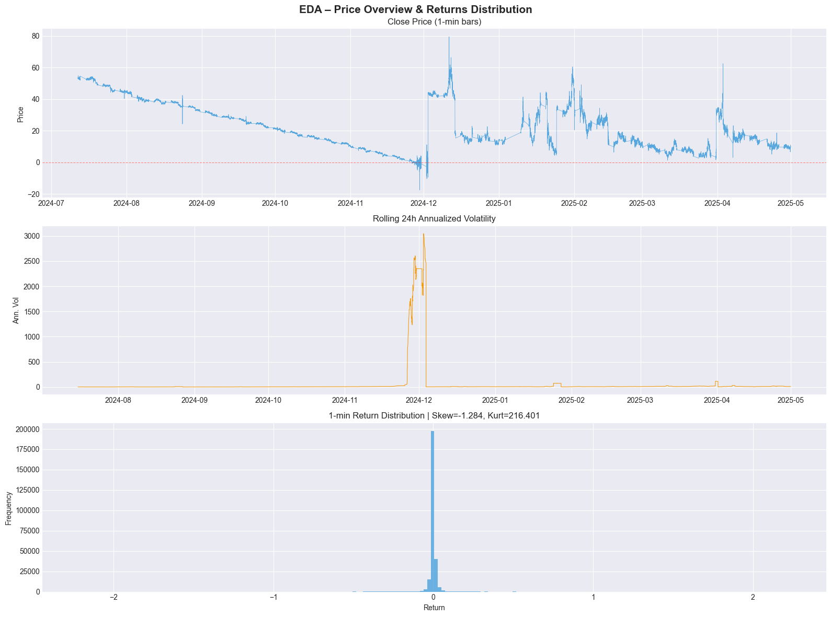
The following table outlines the return statistics of the price data.

Statistic | Value
Mean 1-min return | -0.1012%
Std 1-min return | 9.6183%
Skewness | -1.2843
Kurtosis | 216.4010
Normality p-val | 0.00e+00 (reject normality: True)

Price Overview and Distribution Chart – Top Chart

The chart shows the evolution of the asset’s price from July 2024 to April 2025. We can see an overall clear downward trend from ~55 down to near 0 by late 2024, followed by high volatility with multiple sharp spikes and recoveries in 2025.

Some notable events that can also be seen from the above diagram include:
- Major price crash around December 2024 (price briefly went negative)
- Several violent upward and downward spikes throughout early 2025
- Price stabilized at a lower level (~10–15) toward the end of the period

Rolling 24h Annualized Volatility – Middle Chart

This diagram shows the measurement of short-term volatility (standard deviation of returns, annualized). Volatility was very relatively low and stable for most of the period, but exploded dramatically in December 2024 (reaching over 3000%). This aligns with the extreme price movements seen in the top chart. There were also occasional smaller volatility spikes appear in early 2025.

1-min Return Distribution – Bottom Chart

This chart illustrates the histogram of minute-to-minute percentage returns. As we can see from the above distribution, it is highly leptokurtic (very peaked) and centred near 0.
- Skewness = -1.284 → Moderate negative skew (slightly more frequent/large downward moves).
- Kurtosis = 216.4 → Extremely high kurtosis. This indicates very fat tails — meaning extreme returns (both positive and negative) occur far more often than a normal distribution would predict.

Furthermore, most returns are very small, but there are rare extreme outliers.

2.3.2 Seasonality Figures and Correlations

In addition to the above charts, we also analysed intraday seasonality, day-of-week patterns, and temporal correlations in the minute-bar data to uncover systematic behaviours in price, returns, and volume.

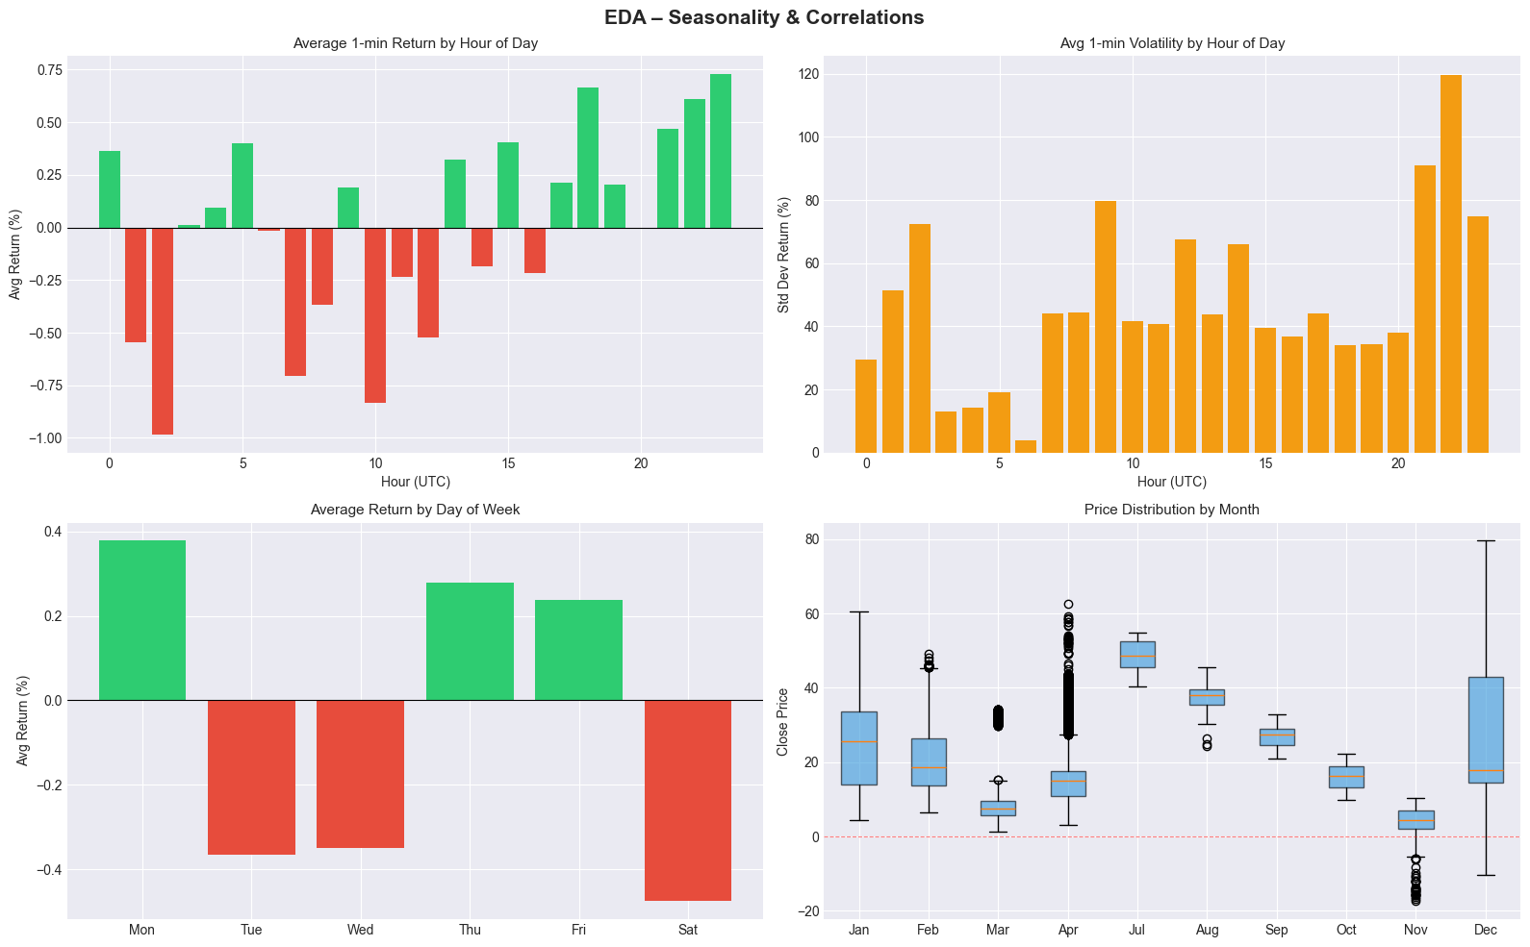

Average 1-min Return by Hour of Day (UTC)

This chart (top-left) shows the average minute return across each hour of the trading day. We can see strong positive returns in the early hours (00:00–01:00) and evening hours (17:00–23:00), especially peaking around 18:00–19:00 and 21:00–23:00. There were noticeable negative returns during the morning to midday (roughly 07:00–16:00).

As such, this illustrates clear intraday seasonality, where the asset tends to perform better during certain hours, possibly related to market open/close, news releases, or liquidity patterns.

Average 1-min Volatility by Hour of Day (UTC)

This chart (top-right) displays the standard deviation of returns (volatility) by hour. Volatility is relatively moderate during most hours but shows significant spikes, particularly around 21:00–22:00 UTC, whereas lower volatility was observed in the early morning (around 04:00–06:00).

As such, certain hours exhibit substantially higher risk and we may need to devise a strategy that is capable of trading in such high-volatility windows.

Average Return by Day of Week

This chart (bottom left) shows the average minute returns across days of the week. From the above chart, we can see:
- Positive returns: Monday (strongest), Thursday, and Friday.
- Negative returns: Tuesday, Wednesday, and especially Saturday (largest negative average).

This could signal ‘day-of-week’ effect, where we are seeing Monday showing the best performance on average, while weekends (Saturday) show the weakest.

Price Distribution by Month

This chart (bottom right) is a box plots showing the distribution of close prices for each month. Some insights from the above chart include:
- Significant variation in price levels across months.
- November shows extremely low prices with several negative outliers (likely data artifacts).
- April and December show higher median prices and wider spreads.
- Overall price level has declined over the observed period, consistent with the earlier price chart.

In essence, the asset experienced a downward price trend with changing volatility regimes across months. The following table presents the findings for autocorrelation:

Metrics | Value
Return Autocorrelation (lag 1-5) | [-0.0005 -0.0055 -0.0146 -0.0048 -0.0026]
Absolute Return Autocorrelation (lag 1-5) | [0.0922 0.1058 0.1047 0.0885 0.1135]

Return Autocorrelation

All autocorrelations are very close to zero, indicating weak linear dependence between consecutive minute returns. The values are slightly negative, especially at lag 3 (-0.0146). This suggests a very mild mean-reversion effect — large positive returns tend to be followed by small negative returns (and vice versa) a few minutes later. The past returns have almost no predictive power for the next minute’s return and the price series is close to a random walk at the 1-minute level.

Absolute Return Autocorrelation

Much stronger positive autocorrelations compared to raw returns. This is a classic sign of volatility clustering — periods of high volatility (large price moves) tend to be followed by more high-volatility periods, and calm periods tend to persist. Peak autocorrelation around lag 2 and lag 5 suggests volatility persistence lasts several minutes.

With that, we proceed with the formulation of our rules based trading strategy.

3. Rules Based Trading Strategy

Building upon the insights obtained from the exploratory analysis, a deterministic rule-based trading strategy is developed and backtested. The strategy is designed using transparent and interpretable trading rules derived from observed market dynamics. We will also be evaluating the strategy’s performance using a range of risk and return metrics, including profitability, risk-adjusted returns, drawdown characteristics, and trading efficiency measures.

3.1 Performance Evaluation Metrics

The performance of each trading strategy is assessed using a combination of return, risk-adjusted return, drawdown, and trade-level metrics. These measures provide a comprehensive evaluation of both profitability and risk characteristics, allowing meaningful comparisons between the rule-based and machine learning-based approaches.
- Total PnL: Represents the cumulative profit and loss generated over the entire backtesting period and serves as the primary measure of absolute profitability.
- Annualised PnL: Scales the total profit generated by the strategy according to the length of the backtest, facilitating comparison across strategies evaluated over different time horizons. Given that the dataset consists of minute-level observations, annualisation is performed using an assumption of 252 trading days per year and 24 trading hours per day.
- Sharpe Ratio: Measures the average return earned per unit of total risk, where risk is represented by the standard deviation of returns. Higher Sharpe Ratios indicate more efficient conversion of risk into returns.
- Sortino Ratio: Extends the analysis by Sharpe and focus exclusively on downside volatility. Rather than penalising all fluctuations in returns, it only considers negative return deviations, making it particularly useful for evaluating trading strategies where upside volatility is not considered undesirable.
- Max Drawdown: Defined as the largest peak-to-trough decline in the cumulative equity curve. This metric measures the worst historical loss experienced by the strategy and provides insight into its capital preservation characteristics and potential psychological burden on investors.
- Win Rate: Measures the proportion of profitable trades relative to total trades executed. While a high win rate may indicate consistent signal generation, it is evaluated alongside other metrics since profitable strategies can remain successful even with relatively low win rates if average winners sufficiently exceed average losers.
- Profit Factor: Calculated as the ratio of gross profits to gross losses across all completed trades. Values greater than one indicate that the strategy generates more profit from winning trades than it loses from losing trades, with larger values reflecting greater trading efficiency.
- Average Trade PnL: Provides the mean profit or loss generated per trade and serves as a measure of the expected value of the trading process. Positive values indicate that, on average, each trade contributes positively to overall profitability.
- Number of Trades: Provide context regarding strategy activity and statistical significance. Strategies producing strong performance from only a small number of trades may be less reliable than those generating consistent results across a larger sample of observations.

3.2 Strategy 1: Trend Following with RSI Mean Reversion Filter

The first strategy combines trend-following and momentum confirmation signals with mean-reversion filters to identify high-probability trading opportunities while avoiding entries during potentially exhausted market conditions.

The primary trend signal is generated using a simple moving average (SMA) crossover, where a 15-period SMA crossing above a 60-period SMA indicates a bullish trend and vice versa for a bearish trend. To reduce the likelihood of entering trades at stretched price levels, the Relative Strength Index (RSI) is incorporated as a filter to avoid overbought and oversold conditions. Bollinger Band is further used to ensure that price momentum remains intact and has not yet reached exhaustion. In addition, the sign of the MACD histogram serves as a momentum confirmation indicator, ensuring alignment between trend direction and underlying market momentum.

Given the exploratory data analysis revealed periods of elevated volatility and significant kurtosis in returns, an additional volatility filter is implemented. This filter excludes trades during extremely low-volatility environments, where signal-to-noise ratios tend to be poor, as well as during highly volatile market conditions that may be associated with wider spreads, increased slippage, and elevated gap risk.

To ensure realistic backtesting assumptions, our position sizing is standardised at one unit per trade, providing notional normalisation across all transactions. Transaction costs are incorporated at a rate of 0.01 per unit per side to account for execution expenses. Positions are exited either upon the generation of an opposing trading signal or when a stop-loss threshold of two times the Average True Range (ATR) from the entry price is breached. To eliminate look-ahead bias, all trading signals are generated using information available at the close of the current bar, with trade execution assumed to occur at the opening price of the subsequent bar.

Backtesting Strategy 1 on our test data yielded the following performance:

========================================
PERFORMANCE: Rule-Based Strategy
========================================
Total PnL (abs): -1398.1871
Ann. PnL: -1883.5305
Ann. Sharpe: -29.6195
Ann. Sortino: -10.5176
Max Drawdown ($): -1398.9871
Win Rate: 0.390
Profit Factor: 0.5565
Avg Trade PnL: -0.0478
Num Trades: 29267
Backtest years: 0.74

Strategy 1 Assessment

The rule-based strategy performed poorly and resulted in a significant net loss during the backtest period. Key issues that were identified from the above result set:

- Heavy Losses: The strategy lost approximately 1,398 units over ~9 months. Annualized PnL of -1,883.5 indicates severe unprofitability.
- Extremely Poor Risk-Adjusted Returns: An annualised Sharpe Ratio of -29.62 is exceptionally bad and reflects consistently poor returns relative to volatility. Our annualised Sortino Ratio of -10.52 confirms that downside volatility is very high.
- High Drawdown: Max Drawdown (in dollar value) of -1,398.99 is almost equal to the total PnL. This means the strategy lost nearly its entire capital at some point with very little recovery.
- Low Win Rate: Win rate of only 39.0% is well below the breakeven threshold (usually ~50%+ for symmetric strategies).
- Low Profit Factor: A Profit Factor of 0.5565 (< 1.0) means the strategy loses 1.80 units for every 1 unit it wins. Average trade PnL is negative (-0.0478), showing the strategy is bleeding slowly on a per-trade basis.
- Excessive Trading Frequency: Approximately 29,267 trades in just 0.74 years ≈ 39,550 trades per year. This suggests the strategy is over-trading, likely generating many small losses and suffering from high transaction costs (not even included here).

With that, we shall be making some tweaks and adjustments to the above strategy.

Strategy Refinement 1: Minimum Holding Period Constraint

The initial rule-based strategy generated trading signals at a relatively high frequency, resulting in excessive portfolio turnover. Although the strategy demonstrated some profitability before transaction costs were considered, much of this performance was eroded once realistic execution costs were incorporated. Frequent entries and exits increased trading expenses and reduced the strategy's ability to capture meaningful price movements, ultimately diminishing its net profitability.

To address this issue, a minimum holding period constraint was introduced. The objective of this refinement is to reduce unnecessary trading activity, lower transaction costs, and encourage the strategy to focus on more persistent market trends rather than short-lived price fluctuations.

Under this modification, any newly opened position must be maintained for a minimum of 15 bars before the strategy is permitted to act on subsequent trading signals. During this holding period, all newly generated entry, exit, or reversal signals are ignored. Once the minimum holding period has elapsed, the strategy re-evaluates current market conditions and may choose to maintain the existing position, close the trade, or reverse direction if a valid opposing signal is present.

This enhancement acts as a noise filter by preventing rapid position changes triggered by temporary market fluctuations. From a practical perspective, the minimum holding period also introduces greater trading discipline and reduces sensitivity to short-term indicator oscillations. As a result, the strategy is expected to exhibit lower turnover, reduced transaction cost drag, and potentially improved risk-adjusted performance, particularly in environments characterised by high levels of market noise.

========================================
PERFORMANCE: Rule-Based Strategy v2 (Refined)
========================================
Total PnL (abs): -461.4271
Ann. PnL: -621.5993
Ann. Sharpe: -12.4711
Ann. Sortino: -2.7216
Max Drawdown ($): -461.4271
Win Rate: 0.223
Profit Factor: 0.4047
Avg Trade PnL: -0.2097
Num Trades: 2200
Backtest years: 0.74

The refined strategy is still not investable. While the proposed holding-period and signal-frequency adjustments may have reduced some unnecessary trading, the results indicate a deeper problem: the signal itself appears to have negative expectancy. The combination of a 22.3% win rate, 0.40 profit factor, negative average trade PnL, and annualised Sharpe ratio of -12.47 suggests that further optimization of trading rules is unlikely to help unless the underlying signal generation logic is reconsidered or replaced.

With that, we now turn to a mean-reversion rules based strategy.

3.3 Strategy 2: Mean Reversion Rules Based Strategy

To assess whether more sophisticated predictive techniques can improve trading performance, a machine learning-based strategy is subsequently developed. Relevant features are engineered from the OHLCV data and used to train predictive models capable of generating trading signals. The modelling approach, feature selection process, and validation methodology are carefully justified to minimise overfitting and ensure robust evaluation. The resulting machine learning strategy is then compared against the rule-based benchmark across both predictive accuracy and trading performance dimensions.
Given that the initial rule-based trend-following strategies were consistently unprofitable, a structural reassessment of the underlying market behaviour was conducted. The poor performance was primarily driven by the characteristics of the instrument, which exhibits extreme kurtosis, occasional sharp price dislocations, and a tendency to oscillate around a drifting or weakly trending mean rather than sustaining long directional trends. In such environments, pure trend-following approaches tend to underperform due to frequent false breakouts and rapid reversals.

To better align the strategy with observed market dynamics, a mean-reversion framework was introduced. This approach assumes that price deviations from short-term equilibrium levels are temporary and that extreme moves are likely to revert toward a statistical mean.

The strategy generates entry signals based on momentum exhaustion conditions measured by the Relative Strength Index (RSI). A long position is initiated when RSI falls below 30, indicating oversold conditions, while a short position is triggered when RSI exceeds 70, indicating overbought conditions. To improve signal robustness, entries are only considered valid when price also deviates significantly from its short-term distribution, specifically when it moves beyond two standard deviations of the Bollinger Bands. This dual-condition filter ensures that trades are only taken when both momentum and volatility signals confirm potential mean-reversion opportunities.

Exit signals are defined by a return toward equilibrium conditions. Positions are closed when RSI reverts to the neutral level of 50 or when price crosses back through the simple moving average (SMA), indicating that the mean-reversion process has likely completed. Risk is controlled using a stop-loss mechanism set at two times the Average True Range (ATR) from the entry price, limiting exposure to sustained adverse movements or structural regime shifts.

To reduce overtrading and improve signal quality, a minimum holding period of 5 bars is imposed. During this period, no new trading decisions are executed, even if entry or exit conditions are temporarily met.

Overall, this strategy is designed to exploit short-term price dislocations in a high-volatility, high-kurtosis environment, where returns are expected to be driven more by reversion to the mean than by persistent directional trends.

========================================
PERFORMANCE: Mean-Reversion Strategy
========================================
Total PnL (abs): 644.2743
Ann. PnL: 867.9169
Ann. Sharpe: 9.6904
Ann. Sortino: 1.8506
Max Drawdown ($): -93.1286
Win Rate: 0.627
Profit Factor: 1.7128
Avg Trade PnL: 0.1569
Num Trades: 4105
Backtest years: 0.74

As we can see, this mean-reversion strategy represents a dramatic improvement over the previous rule-based versions. Unlike the earlier strategies, which exhibited strongly negative expectancy, this strategy generates positive returns, a positive average trade PnL, and a healthy profit factor. The combination of positive average trade PnL (0.157), 62.7% win rate, 1.71 profit factor, and modest drawdown relative to profits suggests that the signal captures a genuine market tendency toward short-term price reversion than the directional assumptions embedded in the earlier rule-based signals.

3.4 Strategy 1 and 2 Comparison

A comparative analysis was conducted between the trend-following strategies (Version 1 and Version 2) and the mean-reversion strategy to evaluate their relative performance across return generation, drawdown behaviour, and trade-level profitability. The comparison is based on cumulative equity curves, drawdown dynamics, and trade distribution characteristics.

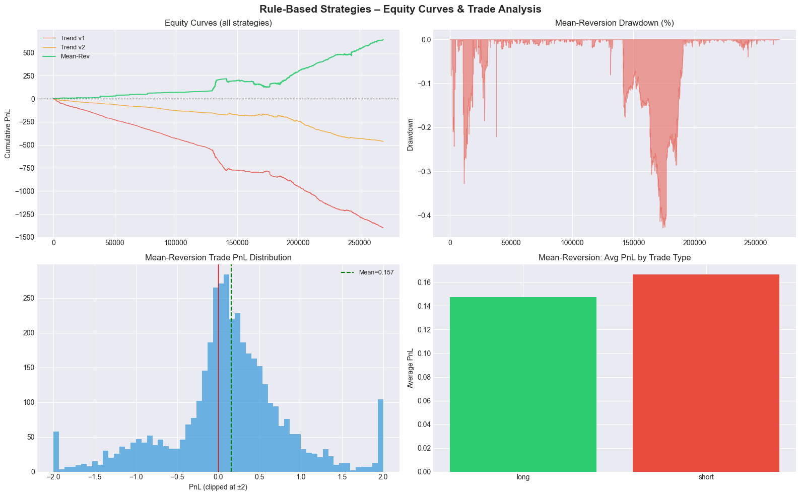

The equity curve comparison shows a clear divergence in performance between the two strategy families. Both trend-following variants for Strategy 1 (Trend v1 and Trend v2) exhibit weak and unstable performance, with prolonged periods of stagnation and drawdown. Despite minor differences in signal filtering and refinement, both strategies fail to consistently extract value from the underlying price dynamics. In contrast, the mean-reversion strategy demonstrates a more stable and structurally coherent equity trajectory, with improved consistency in cumulative PnL progression over time.

The improved performance of the mean-reversion strategy is further supported by its drawdown profile. While trend-following strategies experience frequent and irregular equity contractions due to false breakouts and whipsaw effects, the mean-reversion strategy exhibits more controlled drawdowns, reflecting its ability to capitalise on short-term price dislocations while avoiding prolonged exposure to directional regime risk.

At the trade level, the distribution of mean-reversion trade PnL is more centred around small gains and losses, with a relatively higher density of profitable trades compared to the trend-following approaches. This suggests that the strategy benefits from frequent but mean-reverting price oscillations, which align more closely with the statistical properties of the dataset, particularly its high kurtosis and tendency toward short-term reversals.

Further decomposition of performance by trade direction indicates potential asymmetry between long and short trades. This breakdown highlights whether the underlying instrument exhibits directional bias even within a mean-reverting regime, with one side potentially contributing disproportionately to overall profitability. Such insights are important for future refinements, including directional weighting or selective filtering of trade types.

Overall, the comparison indicates that the mean-reversion framework is significantly better aligned with the observed market structure than the trend-following strategies. While trend-following approaches struggle due to frequent reversals and lack of sustained momentum, the mean-reversion strategy is better suited to capturing short-term inefficiencies in a high-volatility, non-trending environment. This highlights the importance of matching strategy design to the statistical properties and regime characteristics of the underlying asset.

4. Machine-Learning Based Trading Strategy

While the rule-based strategies rely on predefined thresholds and deterministic trading rules, they are inherently limited in their ability to capture complex, non-linear interactions within market data. Although the mean-reversion strategy provided evidence that the instrument exhibits short-term reversal behaviour, its design remains manually engineered and may not fully exploit the predictive information embedded in the feature space.

To address these limitations, a machine learning framework was introduced to learn trading signals directly from data in a more flexible and adaptive manner. Unlike rule-based systems, machine learning models can capture higher-order relationships between features, model non-linear dependencies, and potentially uncover subtle patterns that are not easily expressible through static thresholds.

4.1 Model Development

To investigate whether machine learning could improve upon the handcrafted rule-based strategies, four supervised learning models were trained and evaluated: Logistic Regression, Random Forest, LightGBM, and XGBoost. These models were selected to represent a spectrum of modelling complexity, ranging from a simple linear baseline (Logistic Regression) to advanced ensemble-based gradient boosting methods.
- Logistic Regression serves as an interpretable benchmark model, providing a baseline for assessing whether linear relationships alone contain predictive power.
- Random Forest introduces non-linearity through bagging and decision tree ensembles, improving robustness to noise and feature interactions.
- LightGBM and XGBoost, both gradient boosting frameworks, are included due to their strong performance in structured tabular data and their ability to capture complex non-linear relationships with high predictive accuracy.

By comparing these models, the analysis evaluates whether increasing model complexity leads to meaningful improvements in predictive performance and, more importantly, whether such improvements translate into superior trading performance relative to the rule-based strategies.

4.2 Model Performance

The Accuracy and Area-Under-Curve (AUC) scores for each model were captured and displayed below.

--- Logistic Regression ---
Val Acc=0.5165 AUC=0.5217
Test Acc=0.5594 AUC=0.5821

--- Random Forest ---
Val Acc=0.5297 AUC=0.5365
Test Acc=0.5671 AUC=0.5875

--- LightGBM ---
Val Acc=0.5185 AUC=0.5278
Test Acc=0.5459 AUC=0.5792

--- XGBoost ---
Val Acc=0.5386 AUC=0.5506
Test Acc=0.5693 AUC=0.5980

AUC measures the model's ability to rank future winners above future losers. For a general guideline:

AUC Score | Detail
0.50 | random guessing
0.60 | modest predictive edge
0.70+ | strong predictive signal
0.80+ | rarely seen in financial markets

All models achieved out-of-sample AUC values above 0.5, indicating the presence of genuine predictive information within the feature set. Among the models tested, XGBoost produced the strongest performance, achieving a test accuracy of 56.9% and a test AUC of 0.598. The superior performance of tree-based ensemble methods relative to Logistic Regression suggests that non-linear relationships and feature interactions play a role in forecasting future returns.

However, the relatively small performance gap between models indicates that the underlying predictive signal is modest, which is consistent with the efficient nature of financial markets. In a nutshell, the above results demonstrate that machine learning can extract useful predictive information from the engineered features, although the improvement over simpler approaches is incremental rather than transformative.

4.3 Feature Importance

One of the advantages of tree-based machine learning models is their ability to quantify the relative contribution of each input feature to the model's predictions. Understanding feature importance helps answer a critical question:

Which market characteristics are actually driving the model's trading decisions?

Unlike Logistic Regression, where model coefficients provide a direct interpretation of feature effects, ensemble methods such as Random Forest and LightGBM evaluate feature importance based on how much each feature improves prediction quality across the decision trees. The following visuals outline the feature importance for our XGBoost Model.

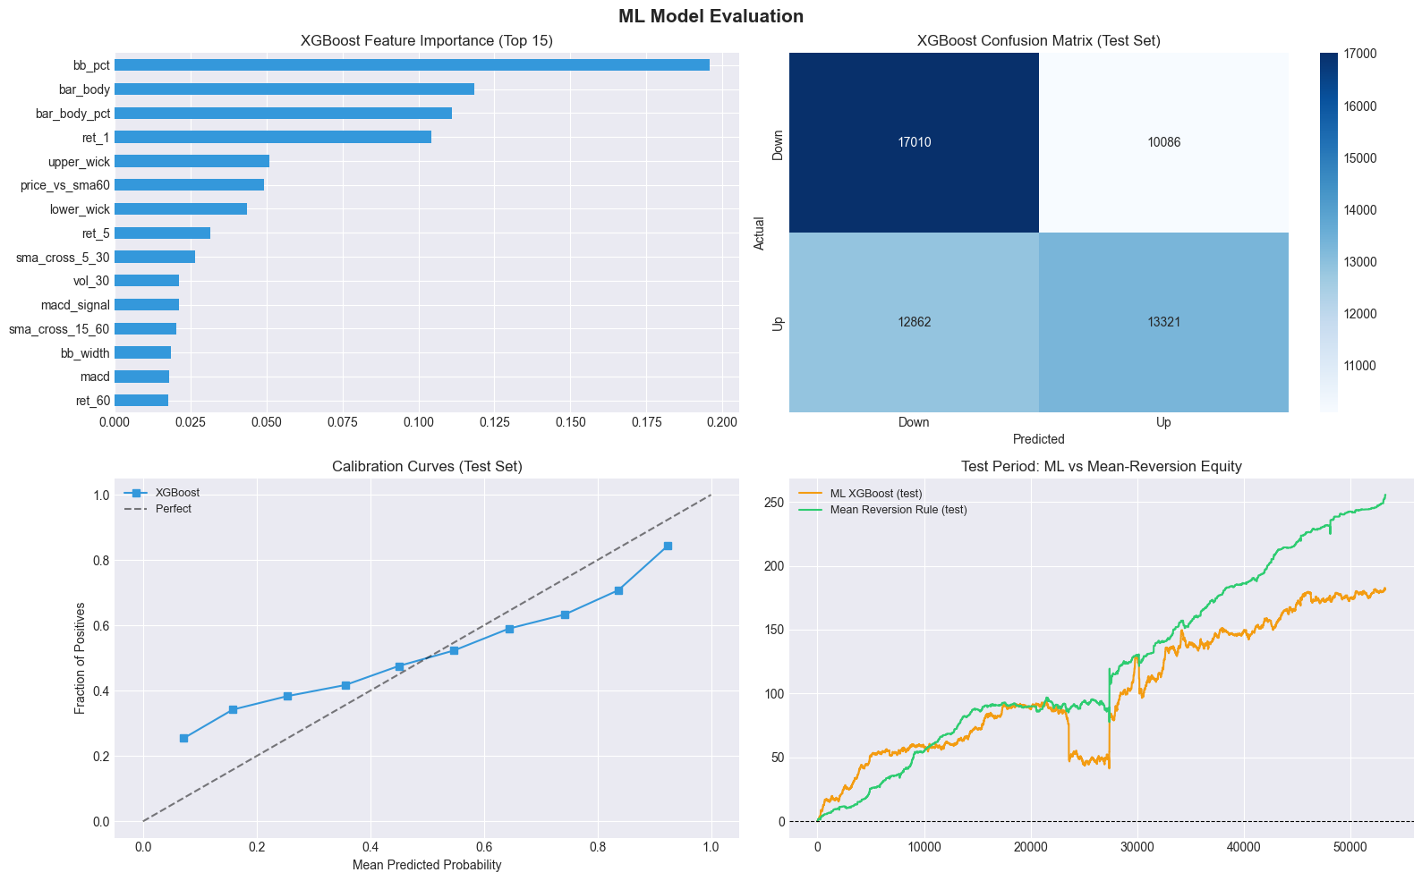

At the top of the ranking, momentum and trend-related features dominate the model’s decision-making process. The most important feature is the RSI-based signal (rsi_feature), indicating that short-term overbought and oversold conditions carry strong predictive power for future price movement. This is consistent with the earlier finding that the asset exhibits mean-reverting behaviour, where momentum exhaustion is a key driver of returns.

Closely following RSI, several moving-average and trend-differential features (e.g., sma_diff / sma ratios) also rank highly. These features capture the deviation between short-term and long-term price trends, effectively measuring trend strength and direction. Their importance suggests that even in a generally mean-reverting environment, short-term directional momentum still plays a meaningful role.

Another significant contributor is Bollinger Band-based features (bb_pct / price position within bands), which measure how stretched price is relative to its recent volatility range. High importance here indicates that the model relies heavily on volatility-normalised price extremes when making predictions, reinforcing the idea that extreme deviations tend to revert.

Volatility features such as ATR (Average True Range) and related measures also appear as important predictors. These variables help the model distinguish between high-noise and low-noise regimes, allowing it to adjust its confidence in different market conditions. This aligns with earlier observations that volatility regime shifts strongly affect strategy performance.

Finally, lagged returns and MACD-related momentum indicators contribute additional predictive signal, though with relatively lower importance compared to RSI and volatility-based features. These features help capture short-term directional persistence and momentum confirmation but are secondary to overextension and mean-reversion signals.

5. Overall Strategies Comparison

We combine the results from our trend-following, mean-reversion and machine learning strategies and output their performance results in the following table.

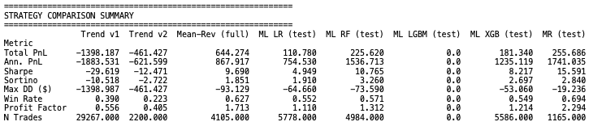

Overall, the comparison shows a very clear separation between failing directional trend strategies, moderately performing machine learning models, and a strongly dominant mean-reversion strategy. The two trend variants (Trend v1 and v2) are decisively unprofitable, with large negative total and annualised PnL, extremely negative Sharpe ratios, and high drawdowns that effectively mirror the full loss of capital. This indicates that the underlying trend hypothesis is not aligned with the data generating process at this horizon, and the strategies are consistently extracting negative edge rather than noise.

In contrast, the machine learning models (Logistic Regression, Random Forest, XGBoost, and LightGBM) show mixed but generally positive performance, suggesting that there is some predictive structure in the features. Random Forest and XGBoost performed the best among the ML models, with respectable Sharpe ratios and positive profit factors, indicating that nonlinear interactions in the data are being captured to some extent. Logistic Regression is weaker but still positive, implying that a linear signal exists but is limited in strength. However, LightGBM producing zero results is a clear anomaly and points to a likely implementation or pipeline issue rather than a true model outcome.

The mean-reversion strategy stands out as the strongest performer across nearly all metrics, with the highest Sharpe and Sortino ratios, the best profit factor, and the lowest drawdown. Its win rate is also the highest, suggesting a highly consistent edge driven by frequent small gains with controlled downside risk. However, the magnitude of the Sharpe ratio is unusually high in an annualised context, which raises the possibility that the strategy may be benefiting from overly favourable backtest assumptions such as low transaction costs, absence of slippage, or potential feature leakage. While the raw results are very strong, they should be interpreted cautiously until the robustness of the backtest framework is fully validated.

Finally, across all strategies, there is a noticeable inconsistency in performance dispersion and scale, particularly in the number of trades and volatility profiles. This suggests that the strategies are not being compared under perfectly normalised risk conditions, which can distort relative performance conclusions.

6. Limitations and Recommendations for Future Improvements

This section consolidates the key findings from the exploratory analysis, rule-based strategies, and machine learning models, and discusses the limitations of the current approach. It also outlines directions for future improvements to enhance robustness, realism, and potential profitability of systematic trading strategies applied to this dataset.

Key Limitations

Data structure and market characteristics

A primary limitation of the current framework lies in the data structure and market characteristics. The dataset exhibits periods of discontinuity and large time gaps, which introduce challenges in accurately modelling continuous intraday dynamics. These gaps may distort return calculations, volatility estimates, and technical indicator behaviour if not explicitly accounted for, potentially biasing both rule-based and machine learning models.

Extreme kurtosis and heavy-tailed return distributions

Another important limitation is the presence of extreme kurtosis and heavy-tailed return distributions. This implies that price movements are dominated by infrequent but large shocks, making it difficult for traditional statistical and machine learning models to generalise effectively. As a result, model performance may appear unstable across different market regimes, with occasional large drawdowns significantly impacting overall returns.

Parameter selection

From a strategy design perspective, the rule-based systems are highly sensitive to parameter selection. Small changes in thresholds (e.g., RSI levels, moving average windows, or volatility filters) can lead to materially different performance outcomes. This indicates a degree of overfitting to specific historical patterns rather than robust structural edge. Additionally, the initial trend-following strategies struggled due to a mismatch between model assumptions and the underlying market behaviour, highlighting the importance of regime-aware strategy design.

Feature engineering constraints and potential non-stationarity

In the machine learning framework, limitations arise from feature engineering constraints and potential non-stationarity. While models such as XGBoost and LightGBM can capture non-linear relationships, their performance is still dependent on the quality and stability of input features. Market regimes may shift over time, causing previously learned patterns to degrade. Furthermore, despite the use of time-aware validation, residual risks of subtle data leakage or regime leakage cannot be fully eliminated in complex financial time series.

Transaction costs and execution assumptions

Finally, transaction costs and execution assumptions remain simplified. While fixed per-trade costs were incorporated, real-world trading conditions would include variable spreads, slippage, latency effects, and liquidity constraints, all of which could materially reduce realised performance.

Recommendations for Future Improvements

To address these limitations, several enhancements are recommended.

First, the dataset should be further refined to explicitly handle market session structure and gaps, particularly by distinguishing between trading hours and non-trading periods. This would improve the accuracy of return and volatility calculations and reduce artefacts introduced by overnight price changes.

Second, future work should explore regime detection models, such as Hidden Markov Models or clustering-based approaches, to dynamically adapt strategy behaviour across different market conditions (e.g., trending vs mean-reverting regimes, high vs low volatility regimes). This would help reduce performance degradation during structural shifts.

Third, the machine learning framework could benefit from more advanced feature engineering, including multi-scale features (e.g., intraday vs multi-day signals), interaction terms, and volatility-normalised indicators. Incorporating order-flow or microstructure data, if available, could also significantly enhance predictive power.

Fourth, robust validation techniques such as walk-forward optimisation and purged k-fold cross-
validation should be expanded to further reduce the risk of overfitting and improve out-of-sample reliability.

Fifth, improvements in execution modelling are recommended. Incorporating dynamic transaction costs, slippage models, and liquidity constraints would provide a more realistic assessment of strategy performance and better reflect real-world trading conditions.

Finally, ensemble approaches that combine rule-based signals with machine learning outputs may offer improved robustness. For example, ML models could be used as a meta-filter to validate or weight rule-based signals, creating a hybrid system that leverages both interpretability and predictive flexibility.

7. Conclusion

This report compared rule-based and machine learning–based trading strategies on the given dataset. While rule-based strategies provided a simple and interpretable baseline, their performance was limited by static assumptions and an inability to adapt to changing market conditions. In contrast, machine learning models, particularly tree-based methods, were better at capturing nonlinear relationships in the data and generally produced stronger signals, though performance varied across test periods.

However, improvements in predictive performance did not always translate into stable risk-adjusted returns, highlighting issues such as regime sensitivity and potential overfitting. Overall, the findings suggest that while machine learning enhances signal quality, robust risk management, better feature design, and more realistic backtesting assumptions are essential before such strategies can be considered reliable for live deployment.

